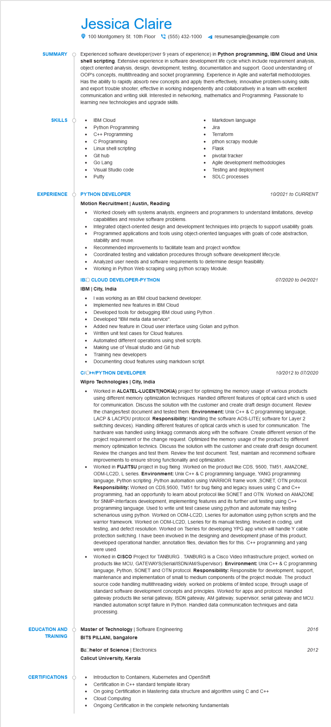
SUMMARY
Jessica Claire
100 Montgomery St. 10th Floor (555) 432-1000
resumesample@example.com
Experienced software developer(over 9 years of experience) in Python programming, IBM Cloud and Unix shell scripting. Extensive experience in software development life cycle which include requirement analysis, object oriented analysis, design, development, testing, documentation and support. Good understanding of OOP's concepts, multithreading and socket programming. Experience in Agile and waterfall methodologies. Has the ability to rapidly absorb new concepts and apply them effectively, innovative problem-solving skills and export trouble shooter, effective in working independently and collaboratively in a team with excellent communication and writing skill. Interested in networking, mathematics and Programming. Passionate to learning new technologies and upgrade skills.
SKILLS
• IBM Cloud
•
Python Programming
C++ Programming
C Programming
Linux shell scripting
Git hub
Go Lang
Visual Studio code Putty
EXPERIENCE Ò PYTHON DEVELOPER
Motion Recruitment | Austin, Reading
•
Markdown language Jira
Terraform
pthon scrapy module
Flask
pivotal tracker
Agile development methodologies
Testing and deployment SDLC processes
10/2021 to CURRENT
• Worked closely with systems analysts, engineers and programmers to understand limitations, develop capabilities and resolve software problems.
•
Integrated object-oriented design and development techniques into projects to support usability goals. Programmed applications and tools using object-oriented languages with goals of code abstraction, stability and reuse.
Recommended improvements to facilitate team and project workflow.
Coordinated testing and validation procedures through software development lifecycle.
Analyzed user needs and software requirements to determine design feasibility.
• Working in Python Web scraping using python scrapy Module.
IBO CLOUD DEVELOPER-PYTHON
IBM | City, India
• I was working as an IBM cloud backend developer.
Implemented new features in IBM Cloud
07/2020 to 04/2021
•
Developed tools for debugging IBM cloud using Python
Developed "IBM meta data service".
Added new feature in Cloud user interface using Golan and python.
Written unit test cases for Cloud features.
Automated different operations using shell scripts.
• Making use of Visual studio and Git hub
Training new developers
• Documenting cloud features using markdown script.
C/C++/PYTHON DEVELOPER
Wipro Technologies | City, India
10/2012 to 07/2020
Worked in ALCATEL-LUCENT(NOKIA) project for optimizing the memory usage of various products using different memory optimization techniques. Handled different features of optical card which is used for communication. Discuss the solution with the customer and create draft design document. Review the changes/test document and tested them. Environment: Unix C++ & C programming language, LACP & LACPDU protocol. Responsibility: Handling the software AOS-LITE( software for Layer 2 switching devices). Handling different features of optical cards which is used for communication. The hardware was handled using linkagg commands along with the software. Create different version of the project requirement or the change request. Optimized the memory usage of the product by different memory optimization technics. Discuss the solution with the customer and create draft design document. Review the changes and test them. Review the test document. Test, maintain and recommend software improvements to ensure strong functionality and optimization.
Worked in FUJITSU project in bug fixing Worked on the product like CDS, 9500, TM51, AMAZONE, ODM-LC2D, L series. Environment: Unix C++ & C programming language, YANG programming language, Python scripting,Python automation using WARRIOR frame work,SONET, OTN protocol. Responsibility: Worked on CDS,9500, TM51 for bug fixing and legacy issues using C and C++ programming, had an opportunity to learn about protocol like SONET and OTN. Worked on AMAZONE for SNMP-Interfaces development, implementing features and its further unit testing using C++ programming language. Used to write unit test casese using python and automate may testing schenarious using python. Worked on ODM-LC2D, Lseries for automation using python scripts and the warrior framework. Worked on ODM-LC2D, Lseries for its manual testing. Involved in coding, unit testing, and defect resolution. Worked on Tseries for developing YPG app which will handle Y cable protection switching. I have been involved in the designing and development phase of this product, developed operational handler, annotation files, deviation files for this. C++ programming and yang were used.
Worked in CISCO Project for TANBURG. TANBURG is a Cisco Video Infrastructure project, worked on products like MCU, GATEWAYS(Serial/ISDN/AM/Supervisor). Environment: Unix C++ & C programming language, Python, SONET and OTN protocol. Responsibility: Responsible for development, support, maintenance and implementation of small to medium components of the project module. The product source code handling multithreading widely. worked on problems of limited scope, through usage of standard software development concepts and principles. Worked for apps and protocol. Handled gateway products like serial gateway, ISDN gateway, AM gateway, supervisor, serial gateway and MCU. Handled automation script failure in Python. Handled data communication techniques and data processing.
EDUCATION AND TRAINING
Master of Technology | Software Engineering
BITS PILLANI, bangalore
Bachelor of Science | Electronics
Calicut University, Kerala
CERTIFICATIONS
Introduction to Containers, Kubernetes and OpenShift
Certification in C++ standard template library
On going Certification in Mastering data structure and algorithm using C and C++
Cloud Computing
Ongoing Certification in the complete networking fundamentals
2016
2012

